FIRST CONDITIONAL

|  |  |  |  |  |  |  |  |  |
| --- | --- | --- | --- | --- | --- | --- | --- | --- |
| C | C | Y | U | L | L | J | B | T |
| A | E | A | V | M | W | K | D | Q |
| C | G | B | X | T | I | W | I | F |
| O | K | W | I | V | L | Y | C | W |
| N | A | O | N | O | L | E | J | M |
| D | O | N | F | P | D | R | L | O |
| I | L | T | I | R | P | U | M | T |
| T | C | I | N | F | Q | T | W | P |
| I | K | L | I | W | R | U | I | R |
| O | J | M | T | F | R | F | B | U |
| N | H | C | I | W | P | R | F | K |
| L | Y | D | V | N | O | P | A | Q |
| U | T | R | E | S | U | l | t | u |
| W | Q | P | O | T | L | M | N | U |

* WILL
* IF
* FUTURE

WONT

* RESULT
* INFINITIVE
* CONDITION

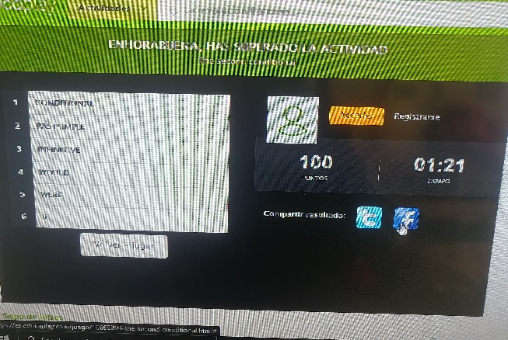

Sopa de letras

crucigrama

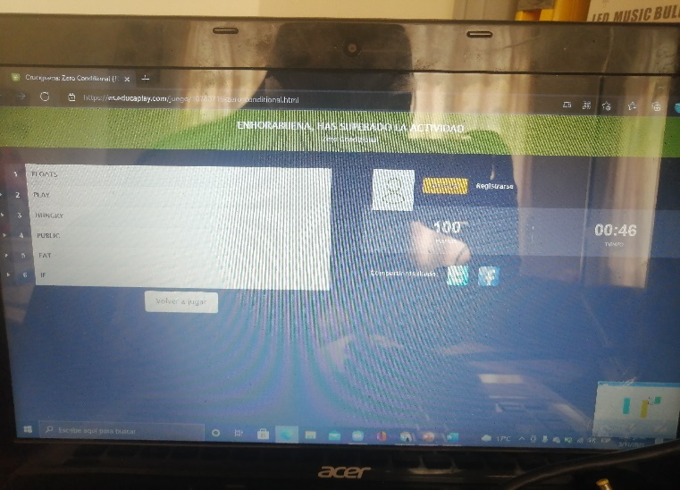

Actividad grupo diego

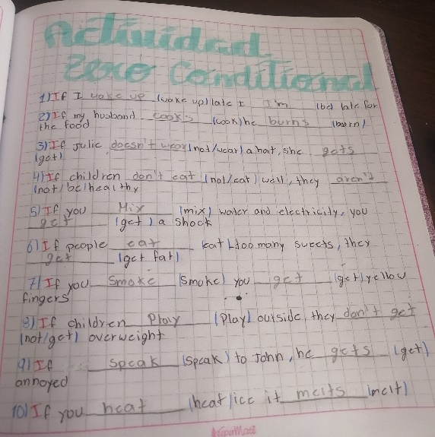 Fernandez reyes dayan lizeth, Prieto Martínez juan Manuel, Ortiz López Javier esteban