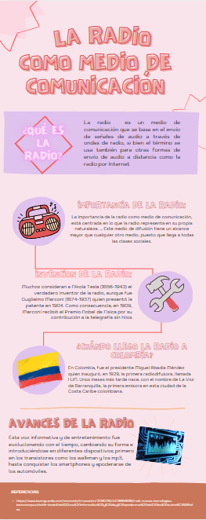

https://www.canva.com/design/DAEldHPtUlA/HSDdlRn-WygFa6vPPToZ7g/view?utm_content=DAEldHPtUlA&utm_campaign=designshare&utm_medium=link&utm_source=publishsharelink