|  |  |  |  |
| --- | --- | --- | --- |
| **COLEGIO PSICOPEDAGÓGICO EL ARTE DEL SABER – WORK GUIDE** | | | |
| **SUBJECT: English** | **GRADE: Fourth** | **Fourth Period.** | **Delivery Date:**  **Oct 23/2020** |

**My Favorite Food**

**Snacks and deserts**

1. Unscramble the following words then match them with the rigth image

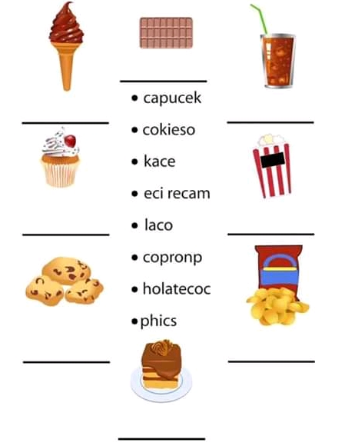

**2.** Draw the following foods on the table:

|  |  |  |
| --- | --- | --- |
| **MILK** | **FISH** | **RICE** |
| **SOUP** | **EGGS** | **BREAD** |

**3.** Choose 3 of your favorite foods, draw them and make a sentence in English with each of them.

**4.**  For our virtual meeting, choose your favorite food, bring it and we will share a pleasant and delicious moment.

1. Choose one of the following figures, cut out and build your favorite.

