|  |  |  |  |
| --- | --- | --- | --- |
| **COLEGIO PSICOPEDAGÓGICO EL ARTE DEL SABER – WORK GUIDE** | | | |
| **SUBJECT: English** | **GRADE: Third** | **Fourth Period.** | **Delivery Date:**  **Oct 16 de 2020** |

**The Months of The Year**

Read and Pronounce:

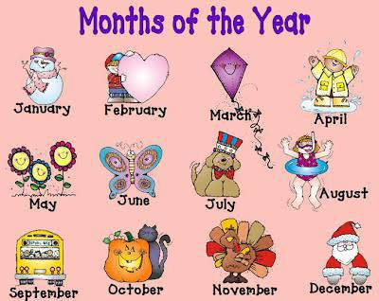

**Activity:**

1. write the months of the year in english
2. Write the following month for each of those listed in the table.

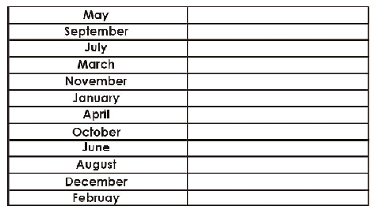

1. Escribe 6 oraciones relacionadas con los meses del año