|  |  |  |  |
| --- | --- | --- | --- |
| **COLEGIO PSICOPEDAGÓGICO EL ARTE DEL SABER – WORK GUIDE** | | | |
| **SUBJECT: English** | **GRADE: Fifth** | **Fourth Period.** | **Delivery Date: September 18** |

**WH QUESTIONS**

* Write the concept in your notebook

The WH questions ask for a specific answer with precise information. They are at the beginning of the sentence. After them, we use the auxiliary verb (do/does). We don´t use **yes** or **no** in the answer.

* The format for WH questions is:

**WH+ do/does + subject +verb + complement..**

**Examples:**

**WH QUESTION ANSWER**

|  |  |
| --- | --- |
| **Who** do you live with? | I live with my son |
| **What** do you like to eat? | I like to eat pizza |
| **Where** does she study? | She studies in Berlin |
| **When does the bus arrive?** | The bus arrives at 7:00 p.m. |

**Exercises:**

**Complete the questions using the WH words**

1. **­­­­**_____________ do you work?

I work in a library

1. ­­­___________do you read?

I read thriller books

1. ___________do you meet your friends?

I meet them at the school

1. __________ do they get to work?

By train.

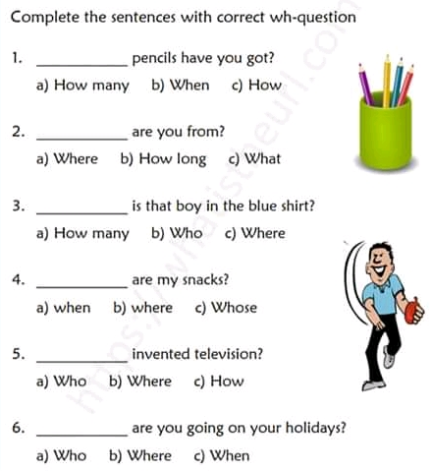

* **Ask the following questions:**

1. What do you do in your free time?
2. When do you go in your free time?
3. When do you normally eat out?
4. What kind of games do you play?

* Write a short paragraph explaining what you do in your free time?

