|  |  |  |  |
| --- | --- | --- | --- |
| **COLEGIO PSICOPEDAGÓGICO EL ARTE DEL SABER – WORK GUIDE** | | | |
| **SUBJECT: English** | **GRADE: Third** | **Fourth Period.** | **Delivery Date: September 18** |

**TRANSPORT MEANS**

The modes of transport can be classified into: Aquatic or maritime, such as: Boat, Submarine, Yacht, boat. Terrestrial, such as: Car, Bicycle, Motorcycle, Bus, trams on tires. Railway, such as the train, the heavy or light metro, the trams on rails.

* Cut and paste:

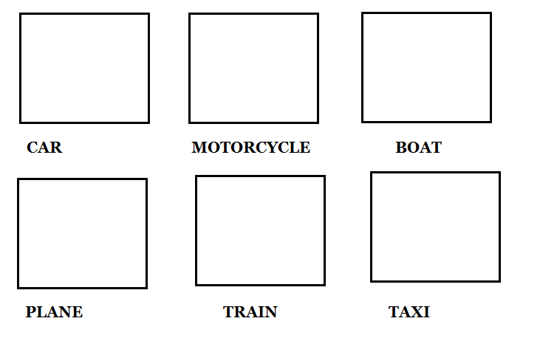

* Complete the crossword:

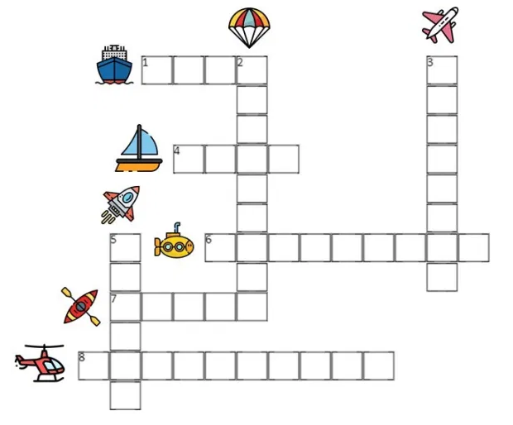

* Write a sentence with each of the following means of transportation and draw:

