|  |  |  |  |
| --- | --- | --- | --- |
|  | | | |
| **ASIGNATURA:ENGLISH** | **GRADO: TRANSICION** | **PERIODO:III** | **FECHA: 16** |

**TEMA: COUNTRY AND CITY Fecha límite de entrega: 16 Agosto.**

1.CUT AND PASTE THE WORD WITH THE IMAGE

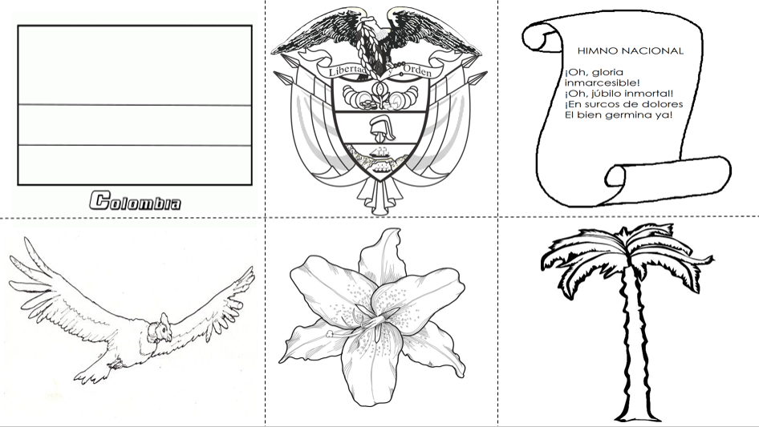 

 

FLAG BOGOTA CHURCH SHIELD