|  |  |  |  |
| --- | --- | --- | --- |
| **COLEGIO PSICOPEDAGÓGICO EL ARTE DEL SABER – WORK GUIDE** | | | |
| **SUBJECT: English** | **GRADE: Third** | **Third Period.** | **Delivery Date:**  **July 31/2020** |

**SOME PROFESSIONS**

Professions or occupations are what people do in their daily work.

**ACTIVITY**

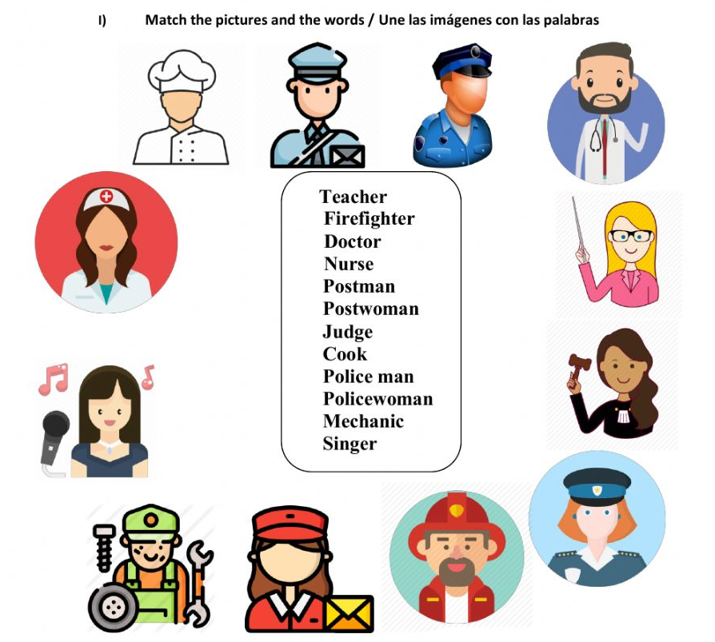

Realiza la sopa de letras y encuentra 7 profesiones en inglés.

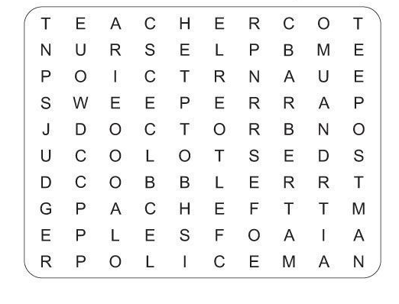

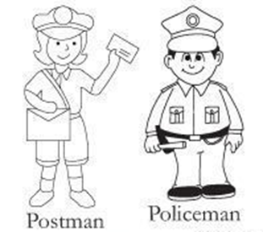

|  |
| --- |
| * For our virtual meeting on Wednesday, July 29, you are going to make your outfit that represents your favorite profession. Prepare your presentation in English and describe your outfit, emphasizing your chosen profession. * Para nuestro encuentro virtual del miércoles 29 de julio vas a elaborar tu atuendo que represente tu profesión favorita. Prepara tu exposición en inglés y describe tu atuendo, haciendo énfasis en tu profesión escogida. **Nos divertiremos.** **We had fun.** |