|  |  |  |  |
| --- | --- | --- | --- |
| **COLEGIO PSICOPEDAGÓGICO EL ARTE DEL SABER – WORK GUIDE** | | | |
| **SUBJECT: English** | **GRADE: Third** | **Third Period.** | **Delivery Date:**  **July 24/2020** |

**Topic: Our Father**

Welcome to this week of studies in which we will work on the prayer that Jesus taught us: **Our Father.**

**Our Father**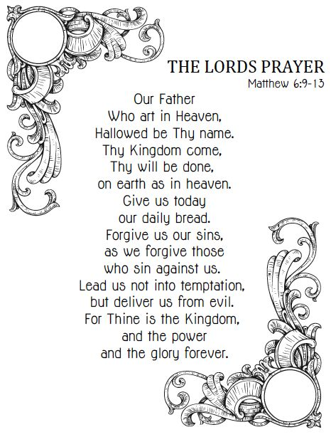

**ACTIVITY**

* Copy the Our Father in your notebook and make an allusive drawing.

Copia el Padre Nuestro en tu cuaderno y realiza un dibujo alusivo.

* Consulta el significado de las siguientes palabras y escríbelo en español:

1. Heaven
2. Kingdom
3. Earth
4. Bread
5. Forgive
6. Against
7. Forever

* Practice the Our Father with the help of the following link:

Practica el Padre Nuestro con ayuda del siguiente enlace:

<https://www.youtube.com/watch?v=MT5ImmJHToQ>

* Make page 27 of your Student Book, which we will work on in our virtual meeting.

Realiza la página 27 de tu Student Book, la cual trabajaremos en nuestro encuentro virtual.