**more ACADEMIC CONTINGENCY PLAN**

**SECOND TERM**

**TEACHER:** Diana Yamile Figueredo **SUBJECT:** English

**COURSE:** Fifth

**DELIVERY DATE**: MAY 22.

**ACTIVITY**

1. Write and make an allusive drawing of the following sentences in order to consolidate vocabulary already studied.

(Escribe y realiza un dibujo alusivo de las siguientes oraciones con el fin de afianzar vocabulario ya trabajado)



* My favourite day of the week is Friday. I work from Monday to Thursday, so I have a three day weekend. I love that, because I can sleep a lot.
* Definitely, Saturday! I can hang out with my friends , watch TV and go to bed late. And I don´t work on Sundays. It´s perfect.

1. Write about your favourite day of the week and tell us the reasons.

**SOME COMMON DAILY ROUTINES**

Every day of the week we carry out daily routines, essential for our life, these are some of them:

1. Draw:

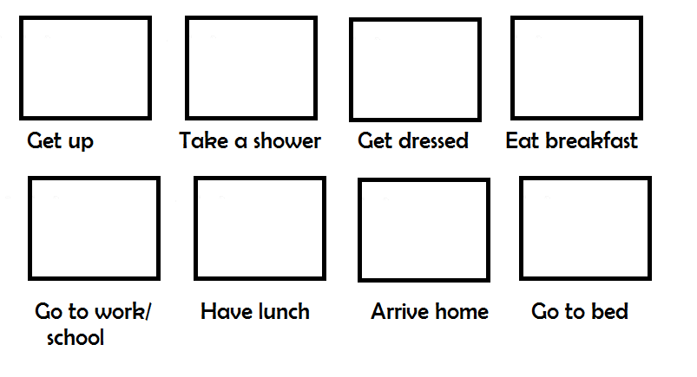

1. Escribe la siguiente conversación y practica su pronunciación con un familiar:

DO YOU WANT TO GO TO THE PARTY?

Melissa: Today is Friday! Do you want to go a party on Saturday night?

Johan: No… I am tired. I have insomnia, and I wake up at 5:30 AM

every morning.

Melissa: Oh…! That´s too early!

Johan: Yes… and I work 10 hours a day from Monday to Friday.

Melissa: What do you do on weekends?. Do you sleep?

Johan: No, I study French.

1. Write your Saturday routine in English and draw. We will discuss this routine in our video class, so prepare it

(Escribe tu rutina del día sábado en inglés y dibuja. Esta rutina la dialogaremos en nuestra video clase, así que estudiala y prepárala)

