COLEGIO PSICOPEDAGOGICO EL ARTE DEL SABE

Completa los números

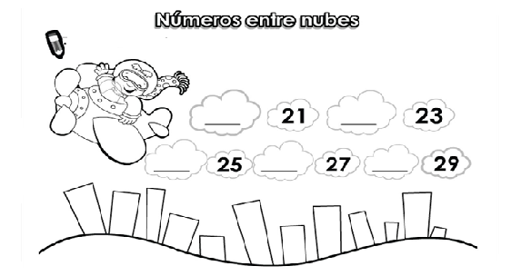

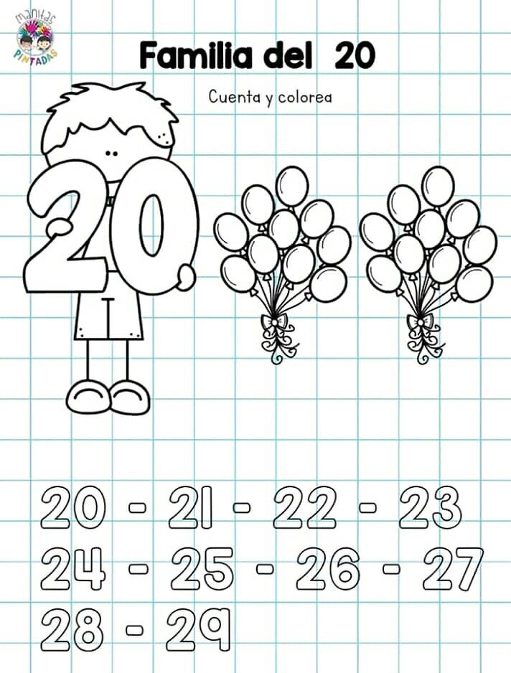

Escribe el nombre de la familia del 20.

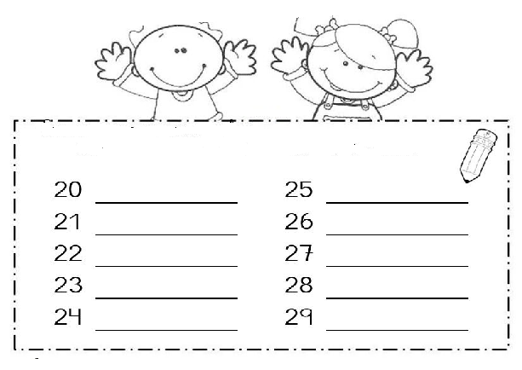

Escribe la serie del 0 al 29 (3 veces).

____ ____ ____ ____ ____ ____ ____ ____ ____ ____

____ _____ _____ _____ _____ _____ _____ _____ ____ ____

____ _____ _____ _____ _____ _____ ____ ____ _____.

____ ____ ____ ____ ____ ____ ____ ____ ____ ____

____ _____ _____ _____ _____ _____ _____ _____ ____ ____

____ _____ _____ _____ _____ _____ ____ ____ _____.

Elaborar una ruleta con los números pares.

2-4-6-8-10-12-14-16-18-20.