**more ACADEMIC CONTINGENCY PLAN**

**SECOND TERM**

**TEACHER:** Diana Yamile Figueredo **GRADE:** Fourth

**SUBJECT:** English

**DELIVERY DATE**: April 24 **THE VERB TO BE**

1. Reading comprehension 

This is Sara. She is nine years old .She is tall and thin. She has long blonde hair. She has small black eyes. She can sing English songs and she can ride a bike. She can’t swim. She can’t read Chinese, her favourite toy is a plane. It’s purple. She has two green kites. She has a blue yoyo too, she has two red balls.

What is her name?

How old is she? ________________________________________

Is she tall? ________________________________________________________

Can she swim?____________________________________________________

Has she short hair?

2.  **PRESENT TENSE OF THE VERB “TO BE”**

Completa con la conjugación correcta del verbo to be (am, is, are), en la forma afirmativa, puedes usar las contracciones (´re, ´s, ´m).

1. I ___ an English student F. The car ____ red
2. You ____ a good person G. Mary ____ sad
3. We____ doctors H. Sam _____ thin
4. He ­­­­____ a lawyer I. The movie ____funny
5. They ____ angry J. Carl and Martha ____ nice.

3. Escribe las oraciones anteriores, pero ahora usando la forma negativa del verbo to be (am not, is not, are not), puedes usar las contracciones (isn´t, aren´t).

4. Escribe 5 oraciones en forma interrogativa, utilizando la estructura del verbo to be para realizar preguntas. Guiate por el ejemplo:

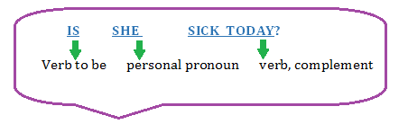

5. Escribe en las nubes los pronombres personales correspondientes para las tres conjugaciones del verbo to be.

